**Groovy Projects**

1. **Groovy Script for Log File Analysis**

**Step 1: Open Nodepad and paste this info and save in the c://user/Administator as server.log text file.**

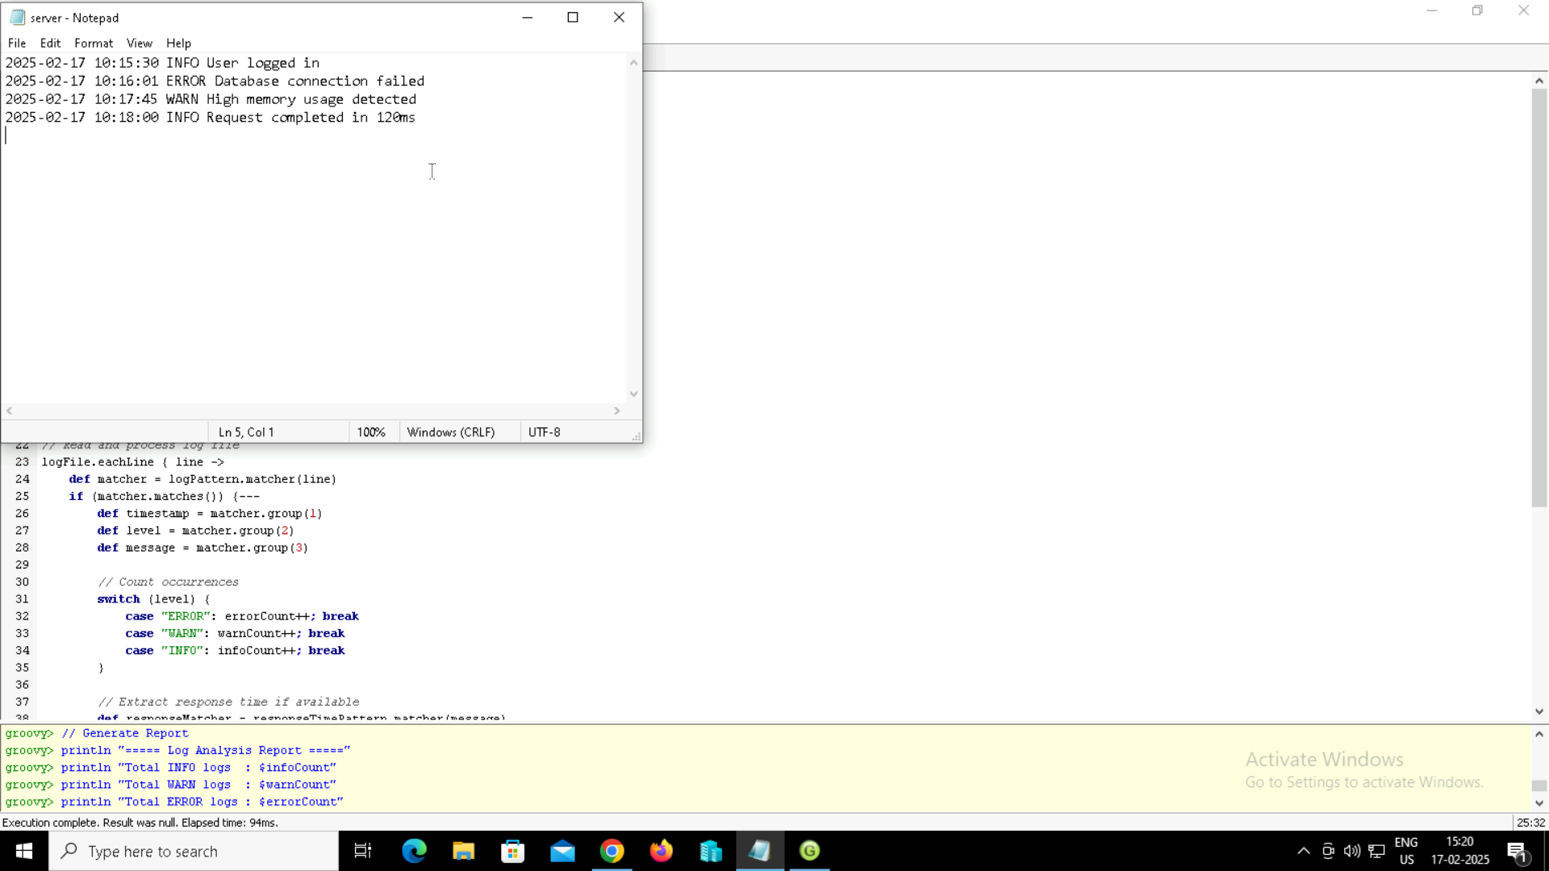

**Step 2: Right the script in the Groovy Console**

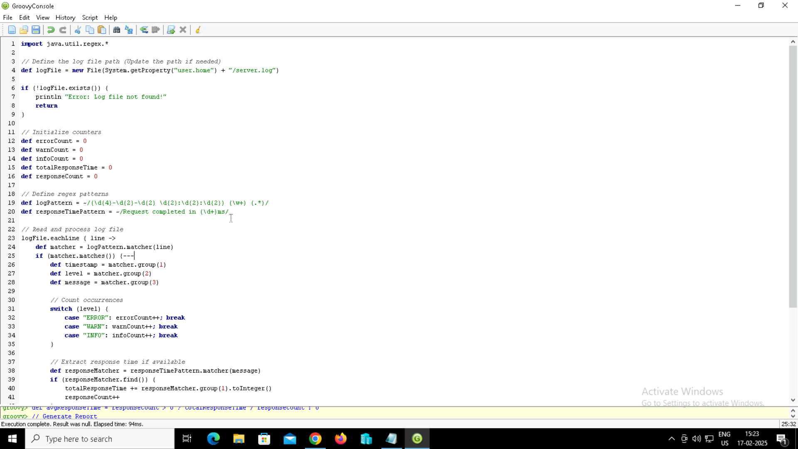

**Step 3: Output**

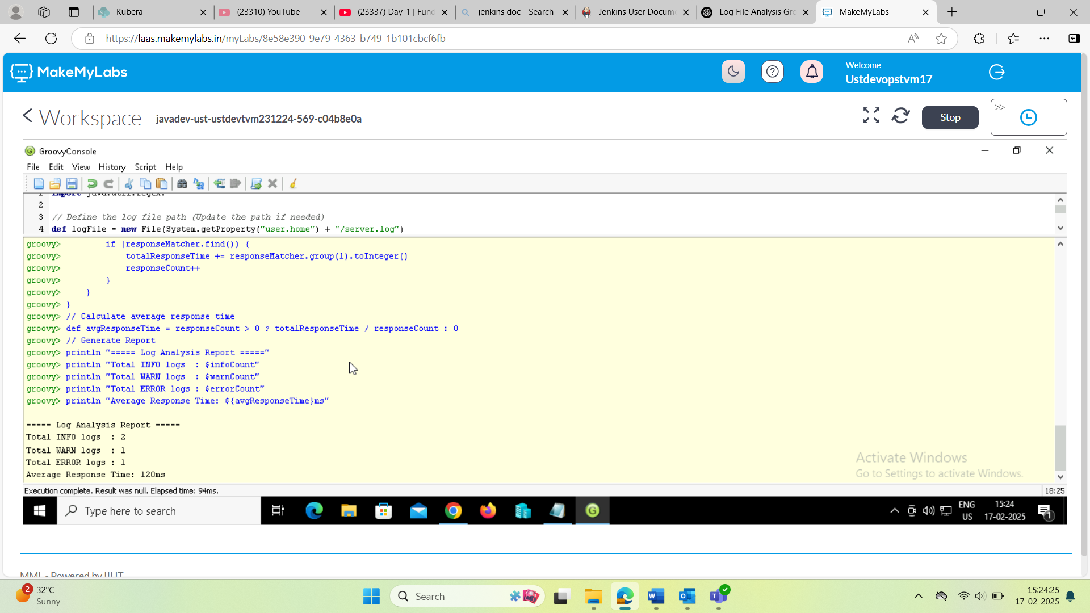

1. **Web Scraping with Groovy & Jsoup**

**Step 1: Run the script in groovy**

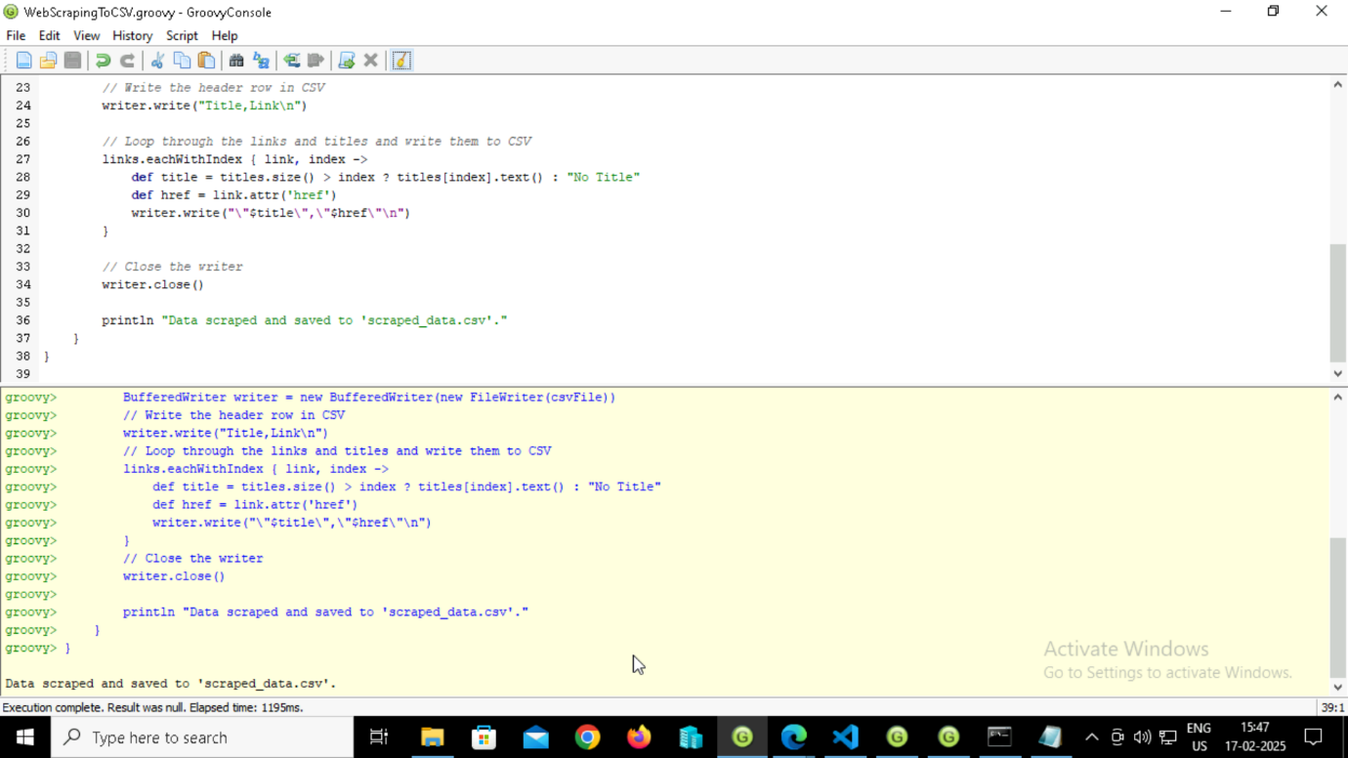

**Step 2: Run the script in terminal**

**Step 3: Output**

